**A Minimalist Robot for *in situ* Exploration of SMALL Bodies**

JPL Task # R.12.023.038

Issa A.D. Nesnas, (PI), Mobility and Robotics Systems Section (347)

Julie Castillo-Rogez (Co-I), Planetary Science Section (322)

Marco Pavone, Stanford (Consultant) *(no cost)*

Robert Reid, Mobility and Robotics Systems Section (347)

Christine Fuller, Mobility and Robotics Systems Section (347)

Kun Ho Kim, California Institute of Technology (summer student)

Paul Hebert, Mobility and Robotics Systems Section (347)

Rudranarayan Mukherjee, Mobility and Robotics Systems Section (347)

Ross Allen, Stanford *(no cost)*

Adam Koenig, Stanford (*no cost*)

# OBJECTIVE

To develop and demonstrate a low-mass minimally-complex robotic platform for the *in situ* exploration of small bodies. The platform would be capable of large surface coverageon the order of a *km2* and finely-controlled regional mobility on the order of 20­–30% of distance traversed [A]. The specific objective is to develop a 5-8 kg internally actuated platform that can demonstrate mobility via hopping and tumbling in microgravity.

# B. STRATEGIC FOCUS AREA

**Robotics, Tele-Robotics and Autonomous System** [1] Mobility

**Science Instruments, Observatories and Sensor Systems** [2] In situ instruments/sensors

# C. RELEVANCE TO STRATEGIC FOCUS AREA

In January 2012, the National Research Council recommended *small body/microgravity mobility* as a high priority technology for NASA to develop over the next five years [1]. Our work makes critical progress toward a capability for *in situ* exploration of small bodies using low-mass robots that provide both large-scale coverage and fine maneuvers (kilometers to meters). With appropriate instrument package, this capability would enable physical and chemical characterization of surface properties relevant to both human and science exploration missions, addressing objectives described in the Decadal Survey for planetary science [1] and the Strategic Knowledge Gaps for Human Exploration [2]. Data obtained from recent missions show that surface properties on most small bodies evolve over scales of hundreds of meters to as little as few meters; this is in contrast to the long-held idea that the surfaces of small bodies are, in general, both chemically and physically homogenous. As a consequence, spatially-extended *in situ* measurements are pivotal to properly constraining regolith properties and surface physics. This effort could better position JPL to compete for future *Discovery* and *New Frontiers* missions to explore small bodies.

# D. APPROACH AND RESULTS

# Our approach to small body mobility is to take full advantage of the microgravity environment rather than face it as a constraint to overcome. To further our understanding of microgravity mobility, we are not only developing analytical models and simulations but also complementing them with physical experiments. We are comparing results from these experiments with ones obtain from physics-based simulations to validate our models.

# Given our limited resources, for our experiments we have adopted a low-cost gravity-offloaded test bed. With such a test bed, only certain phases of the simulation can currently be validated, such as initial hop angle and single step unidirectional tumbles. These limitations result from the lack of an active planar gantry and from the pendulum effect that is offloading the platform’s weight. Having developed a complete prototype though, we are now at a stage where we can bid the ZeroGravity flight opportunity call that comes out quarterly. These flight experiments would enable us to conduct a more accurate and comprehensive evaluation of our system and simulation models. The high cost of microgravity experiments precluded their exclusively use for studying microgravity mobility for small research tasks.

1. Mission Architecture

In one scenario, based on mission architecture concepts developed under a NIAC Phase I in 2011 (PI: Marco Pavone), a mother craft would travel to the vicinity of a small body, such as an asteroid or Mars’ moon, Phobos. It would then deploy one or more 5­–10 kg platforms that would be capable of acquiring measurements from body-mounted instruments at disparate locations, which would be designated by scientists on the ground. Such platforms would traverse using hopping for large coverage and tumbling for finer maneuvers (Figure 1). Using synergistic operations with their mother craft, these platforms would map their environment, localize themselves, receive commands to traverse to designated targets and send telemetry to back to Earth via the mother craft. They would acquire their energy via solar panels to charge their batteries. Due to the limited available energy from small solar panels, they would have short operational duty cycles. The low mass and complexity of these platforms would make them affordable and their numbers would allow for higher-risk higher-reward exploration. This project focuses on the mobility of these platforms to allow *in situ* measurements.

While mobility may be achieved with different actuation methods, we have adopted an approach that uses internal actuation primarily to reduce risk of exposure of the moving parts to fine dust. The internal actuators are encapsulated in a cubic shell with external spikes terminated with ground contact pads (Figure 2). The spikes are arranged in a pre-defined geometry to improve tumbling performance. There are multiple options for internal actuation that generate mobility. We selected to study mutually-orthogonal flywheels to allow three operational modes: (a) hopping, for long-range traverses and large surface coverage, (b) tumbling, for short-range traverses to specific locations of interest, and (c) pseudo-orbiting flight, for high-altitude surface observations or communication [B]. The basic concept behind a flywheel-based option is the conservation of angular momentum, which ensures that the angular momentum can be transferred between the platform and its flywheels. In the absence of external torques, the total angular momentum stays constant, and by controlling the rotation of the three flywheels, one has full control authority to modify the angular rotation vector of the platform (i.e., create a 3D torque on the platform). By appropriately generating a torque, one can control the reaction forces of the surface against the tips of the spikes or footpads, and hence obtain (depending on the torque's control history) either tumbling (i.e., pivoting around the spikes) or hopping when the reaction forces are large enough. Alternative internal actuation methods, such as linear actuation of internal masses, are currently being investigated at Stanford under a JPL CIF project.

1. Modeling and simulations

In the first year, we have developed a 2D Newtonian model of the platform and simulated it in Matlab to analyze the dynamics of its motion and assess the feasibility of separating tumbling from hopping motions under ideal conditions (flat terrain). We modeled the terrain using a spring/damper model. As a verification step, we also implemented a model of a single flywheel using the high-fidelity ADAMS dynamic simulation package with the same flat terrains for initial comparisons. We conducted parametric tests to analyze the impact of the spring/damper constants on the platform’s motion. For the control, we used an open-loop current setting to accelerate the flywheel without any feedback for the torque. The results of these simulations gave us confidence that, at least, under ideal conditions, the platform can carry out controlled hops and tumbles. These results also revealed that in many cases, the forward thrust may not be the result of the reaction on the spike that is contacting the ground at the start of the motion, but rather, the reaction forces on subsequent spikes that hit the ground after the platform has started its hop. Subsequent spikes with high angular velocity hit the ground at a more perpendicular angle causing a large forward thrust. The rover’s angular velocity increases more than ten-fold once the platform gets airborne [C]. This is due to the difference in inertia between pivoting around the two front spikes and spinning around the center of mass once airborne.

Our next step was to investigate the dynamics with more realistic terrains based on topographic data from prior missions. We selected the JPL-developed M3tk high-fidelity physics-based simulation since it provides a capability to integrate our control algorithms. We have made progress toward a contact model of the platform with the terrains but further investigation is still necessary.

One the major limitations of our models has been the fidelity of the contact model of the platform with the terrain. We have conducted experiments with granular media simulations (using GRAMMS [3]) to further our understanding of the contact/regolith interaction. In particular, we investigated the interaction of the spikes with the granular media using lunar regolith terrain properties, which are expected to be a relatively close analog (Figure 4). It is currently not well understood how these particles might react under microgravity. In order to obtain the needed external torques, simulations were done using a single spike with a prescribed motion trajectory into the granular bed. This produced external forces on the spikes, which would be used to determine the external torque needed to produce such a trajectory. The granular bed simulated millions of two different spherical particles (different both in size and properties). The spike motion trajectory consisted of a linear velocity and a rotation. These simulations differed by varying 3 different parameters: (1) linear velocity, (2) angular velocity, and (3) penetration depth into the media. Each parameter was varied while keeping the other two constant in order to analyze each parameter’s impact on the reaction forces. We concluded that the penetration depth affected the external forces the most. As a result, a dynamic simulation with feedback is needed to ascertain the resting penetration depth of the spike. In addition, the effect of spike design on the resting depth should also be investigated.

In addition to these simulations, we used Lagrangian mechanics to develop the equations of motion. From that analysis, we identified four phases of spike/terrain contact for the tumbling motions. When the flywheel is rapidly accelerated/decelerated with the platform starting at rest on a flat surface, the spikes will be gripped to the surface if the horizontal force is less than the maximum static Coulomb friction force. In this phase, the platform will start pivoting around the front spikes. As the angle between the spike and the vertical decreases, the contact point will begins to slide (phase 2). Once the flywheel comes to a complete stop, the contact point will regain its grip (phase 3). Just before the completion of a tumble, the hedgehog will likely slide again before it comes to rest (phase 4). Figure 3 shows the different phases of a tumble.

1. Mobility Platform Design

To complement our simulation work, we designed and fabricated two robot prototypes at JPL to study hopping and tumbling mobility in microgravity. We term these robots “Hedgehogs.” Both prototypes employ internal actuation using flywheels to generate an external torque on the platform, which in turn imparts mobility.

The first prototype used a single flywheel (mass: 0.55 kg; inertia: 8.07×10-4 kg m2) driven by a brushless motors (max torque: ~0.16 Nm 2814/06 from HobbyPeople) with a speed resolver. It was controlled using a hobbyist speed controller commanded from a low-cost Arduino programmable board. By accelerating and decelerating the flywheel, we impart mobility. This prototype was tested in the gravity-offloaded test bed that simulated 0.02 g. The lower bound on the gravity level was constrained by the friction in the pulleys. We then compared the experimental results with those generated by the ADAMS and the Matlab simulations. These experiments provided a first order validation of the ability of such platforms to differentiate between hopping from tumbling in microgravity when tested on hard flat surfaces, sand, and soft surfaces (simulated using foam material).

The second prototype used three mutually-orthogonal flywheels. Given the complexity of studying tumbling motion in our gravity-offloaded test bed, we sought to design a platform that could not only operate in microgravity but could also tumble in Earth’s gravity. We optimized the design to maximize flywheel inertia while minimizing overall Hedgehog inertia. The conical-shaped flywheels (mass: 0.59 kg; inertia: 9.48×10-4 kg m2 each) are mounted close to the center the craft (red colored cones in Figure 2). They are powered using brushless motors with a maximum torque rating of about 0.16 Nm (2814/06 from HobbyPeople). The motors use quadrature optical encoders with 360 resolution (E4P-360-157-N-D-H-M-3 from U.S. digital). This prototype is equipped with CombiPerm permanent magnet brakes (P/N 05P131X-002U) from KEBAmerica (mass: 0.28 kg; torque: 4.5 Nm). The avionics for this platform use a PC104+ stack that includes an Atom N450 1.66 GHz processor (Advantech PCM-3362), a three-channel IEEE1394 FireWire card (CM17208HR from RTD) for image acquisition, and a CAN bus card to communicate with the motor controllers (PCAN-PC/104-Plus IPEH-002094 from Peak). The motors use the Elmo Whistle controllers mounted on a JPL-custom motherboard that uses a pulse-width modulation signal to control the brakes. The Hedgehog is powered with one or more 11.2 V Lithium polymer rechargeable batteries and uses an HE104-DX DC/DC power converter from Tri-M Engineering. This design used commercial-off-the-shelf parts to minimize hardware cost. A CubeSat-like enclosure houses the motors, flywheels, brakes, and avionics (currently mounted externally to reduce mass for 1 g tumbling). The exterior of the craft is covered with spikes in a polyhedral configuration to provide the contact geometry and protect the platform’s interior. The spikes were built from 0.25” cross-braced carbon fiber tubes with aluminum mounts and spherical end effectors (Figure 2 left).

1. Experimental Results

We have tested the tumbling capability of the 3 DoF prototype under Earth’s gravity as well as its hopping capability in the microgravity test bed. We have successfully demonstrated the ability of this prototype to achieve controlled tumbles by spinning up the flywheels to speeds of 6000 – 9000 RPMs and then applying the external brake. By sequencing the flywheels’ motions, the Hedgehog demonstrated six or seven controlled tumbles in multiple directions across a flat surface. We have used a slight incline (5**°**­–10**°**) and a foam surface to reduce required torque for tumbling as the brakes were only able to generate a maximum of 3.3 Nm of torque from 6000 RPM (2.8 Nm from 9000 RPM). At 5.3 kg and with a spike radius of 0.135 m (from the center), the 3 DoF Hedgehog needed a minimum torque of 3.5 Nm to tumble. From the results, we observed that the brake performance had a fairly large and perhaps inconsistent temperature dependency that would either have to be modeled or managed (Figure 5). While the motor controllers would be capable of generating sufficiently high torques for hopping/tumbling in microgravity without the brakes, they needed the brakes for our experiments in Earth’s gravity. We acquired images during the tumbling from cameras mounted on the Hedgehog.

# E. SIGNIFICANCE OF RESULTS

The results are an important first step in the investigation of microgravity mobility. The development of simulations, prototypes and test beds enable us to further study the potential of minimal multi-modal (tumbling/hopping) platforms for surface exploration of small bodies.

**F.      NEW TECHNOLOGY**

Relevant NTR numbers: 48136

# G. FINANCIAL STATUS

The total funding for this task was $180,000, all of which has been expended.

**H.      ACKNOWLEDGEMENTS**

We like to thank the Office of Chief Scientist and Technologist for their support and Prof. Jeffrey Hoffman and his student Tam N. Nguyen who conducted the experiments with the 1 DoF protoype. This work was performed at JPL under contract to the National Aeronautics and Space Administration.

# I. PUBLICATIONS, MEDIA AND PRESENTATIONS

* 1. J.C. Castillo-Rogez, M. Pavone, I.A. Nesnas, and J. Hoffman, “Observational Strategies for the Exploration of Small Solar System Bodies,” *IEEE Aerospace Conference*, Montana, March 2012
  2. R. Allen, et.al., “Internally-Actuated Rovers for All-Access Surface Mobility: Theory and Experimentation,” in Int’l Conf on Robotics and Automation, 2013
  3. A. Koenig, M. Pavone, J. Castillo, I. Nesnas, “A Dynamical Characterization of Internally-Actuated Microgravity Mobility Systems,” Int’l Conf on Robotics, 2014 (submitted)
  4. I.A. Nesnas, M. Pavone, J.C. Castillo-Rogez, “Affordable Surface Mobility for Microgravity Bodies Using Hopping / Tumbling Robots,” abstract submitted to Low-Cost Planetary Mission

# J. REFERENCES

[1] S. Squyres et al. (2011), “Visions and Voyages,” National Research Council Decadal Survey

# [2] M.J. Wargo (2012), “Strategic Knowledge Gaps: Planning for Safe, Effective, and Efficient Human Exploration of the Solar System,”

# K . FIGURES

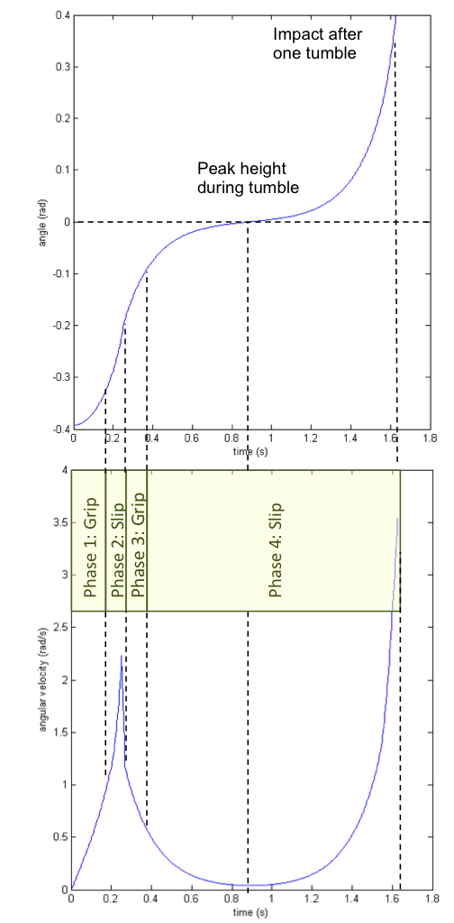

**Figure 3:** Simulation of tumbling phases on a flat surface: (1) grips when horizontal force is less than the maximum static Coulomb friction force; (2) slides around 0.17s, (3) grips when flywheel completely stops at t = 0.25s; (4) slides at 0.37s before tumble is complete

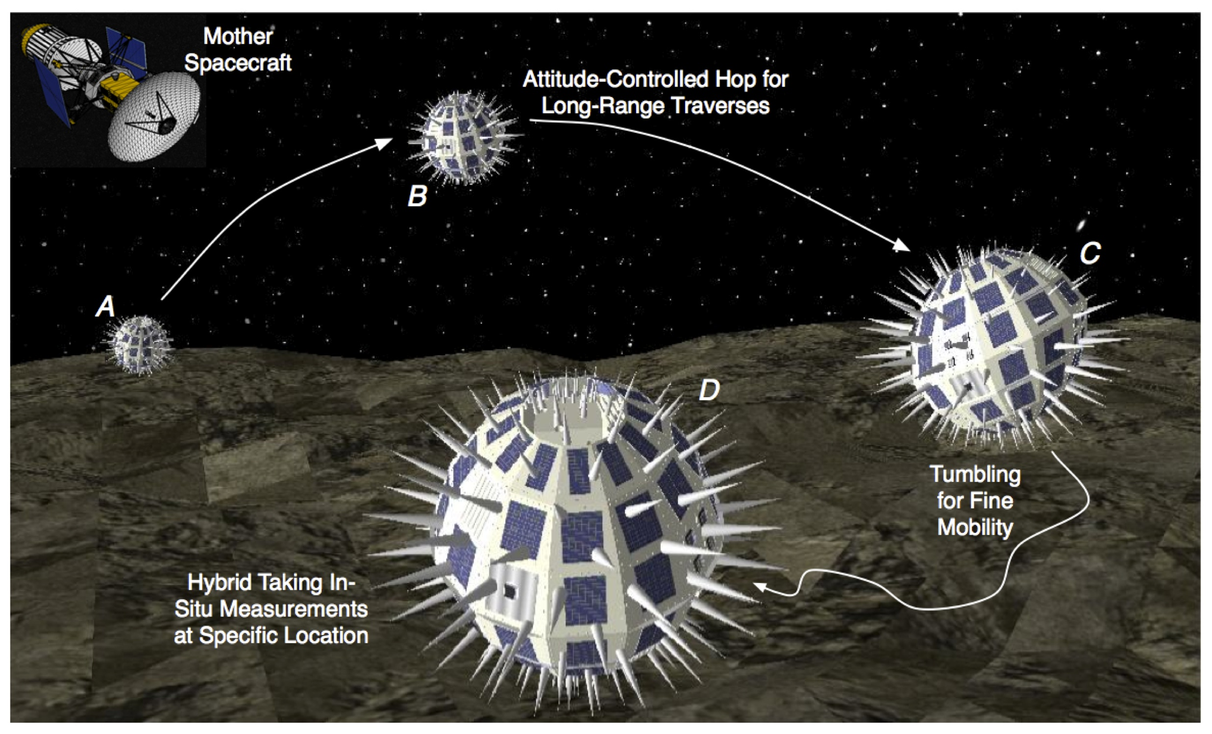

**Figure 1:** The overall mission architecture: mother spacecraft would deploy on the surface of a small body one (or more) spacecraft/rover



**Figure 5:** Variability in the brake

deceleration profiles

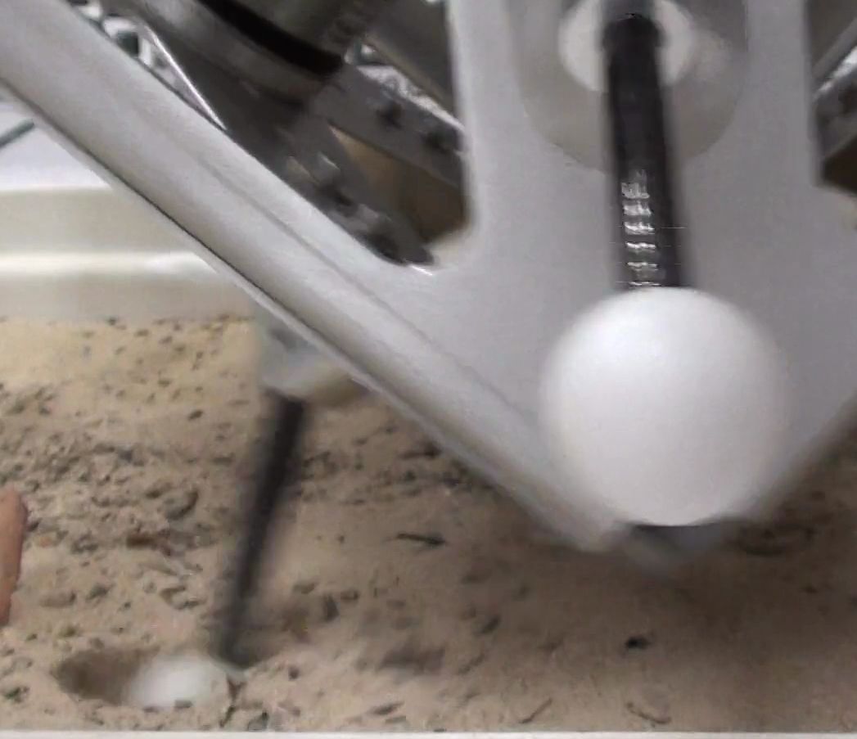 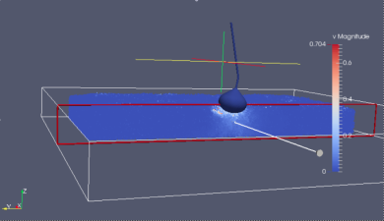

**Figure 4:** (left) video capture of Hedgehog during tumbling motion on sand, (right) simulation of a single spike using GRAMMS granular media simulation

**M.   COPYRIGHT STATEMENT**

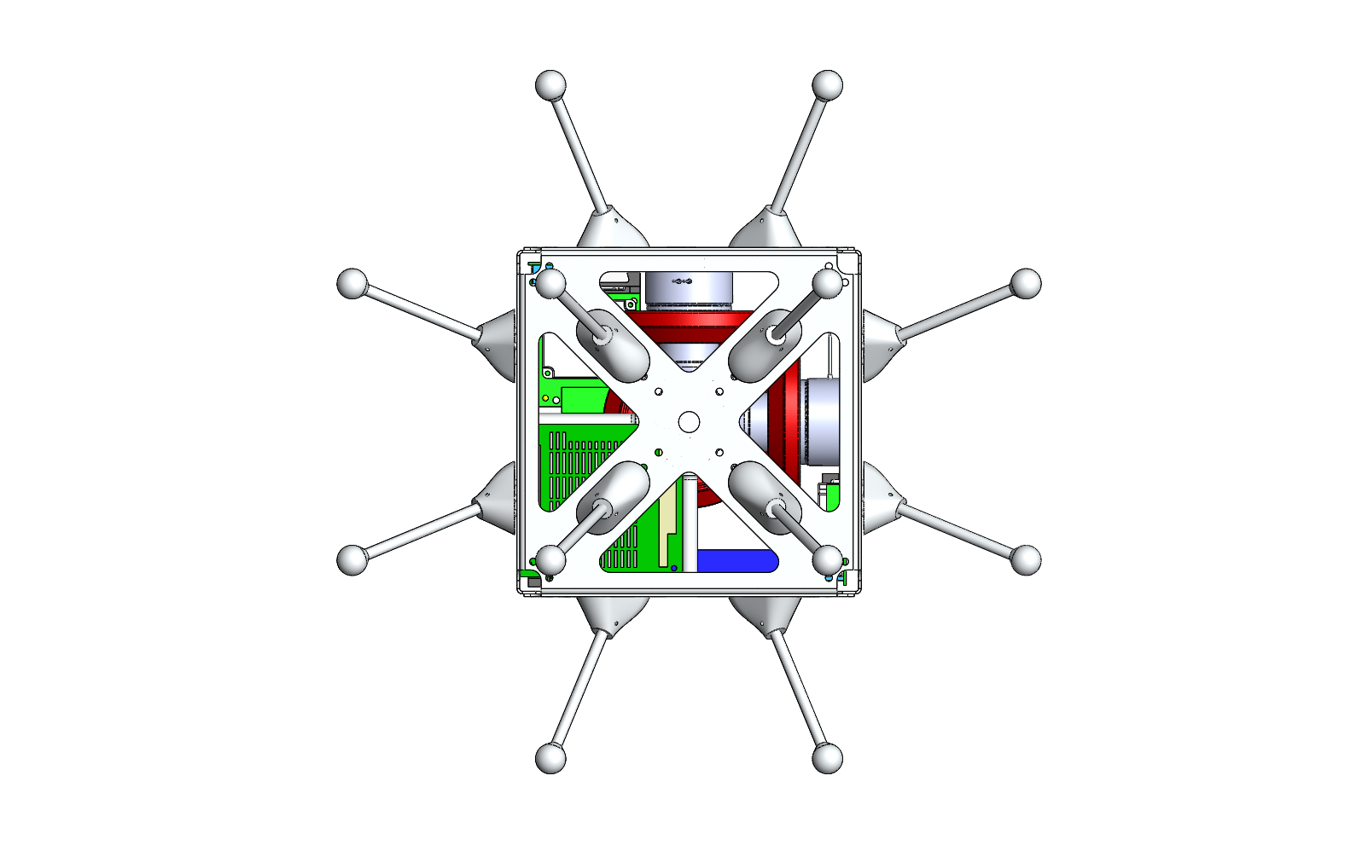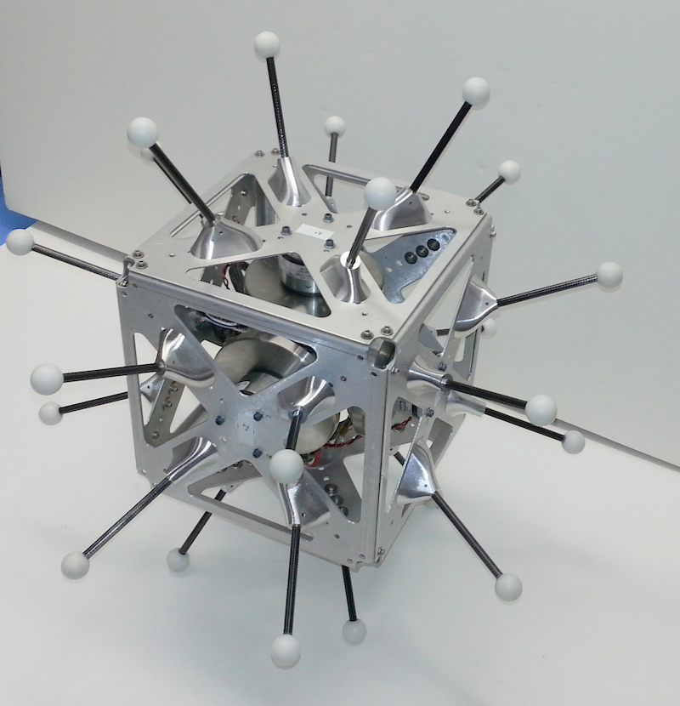

**Figure 2:** (left) mobility platform design, (right) hedgehog prototype with three mutually orthogonal flywheels and brake for 1 g operation

Copyright 2013 California Institute of Technology. Government sponsorship acknowledged.